MultiAx Machine Configuration Tool Layout

- Reference Link for the configuration tool.
https://maingear.com/maingear-mg-1-live-3d-configurator/

Reference Image of Configuration Tool.

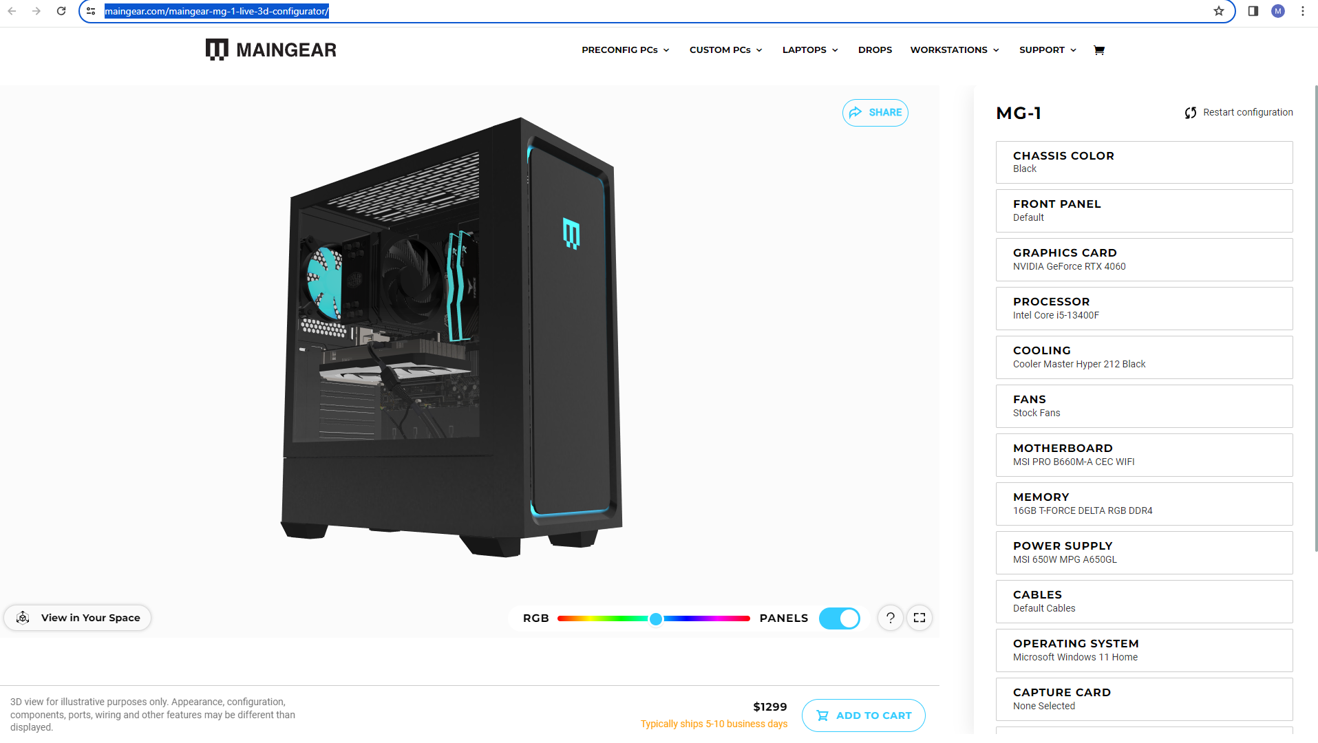
Image-1
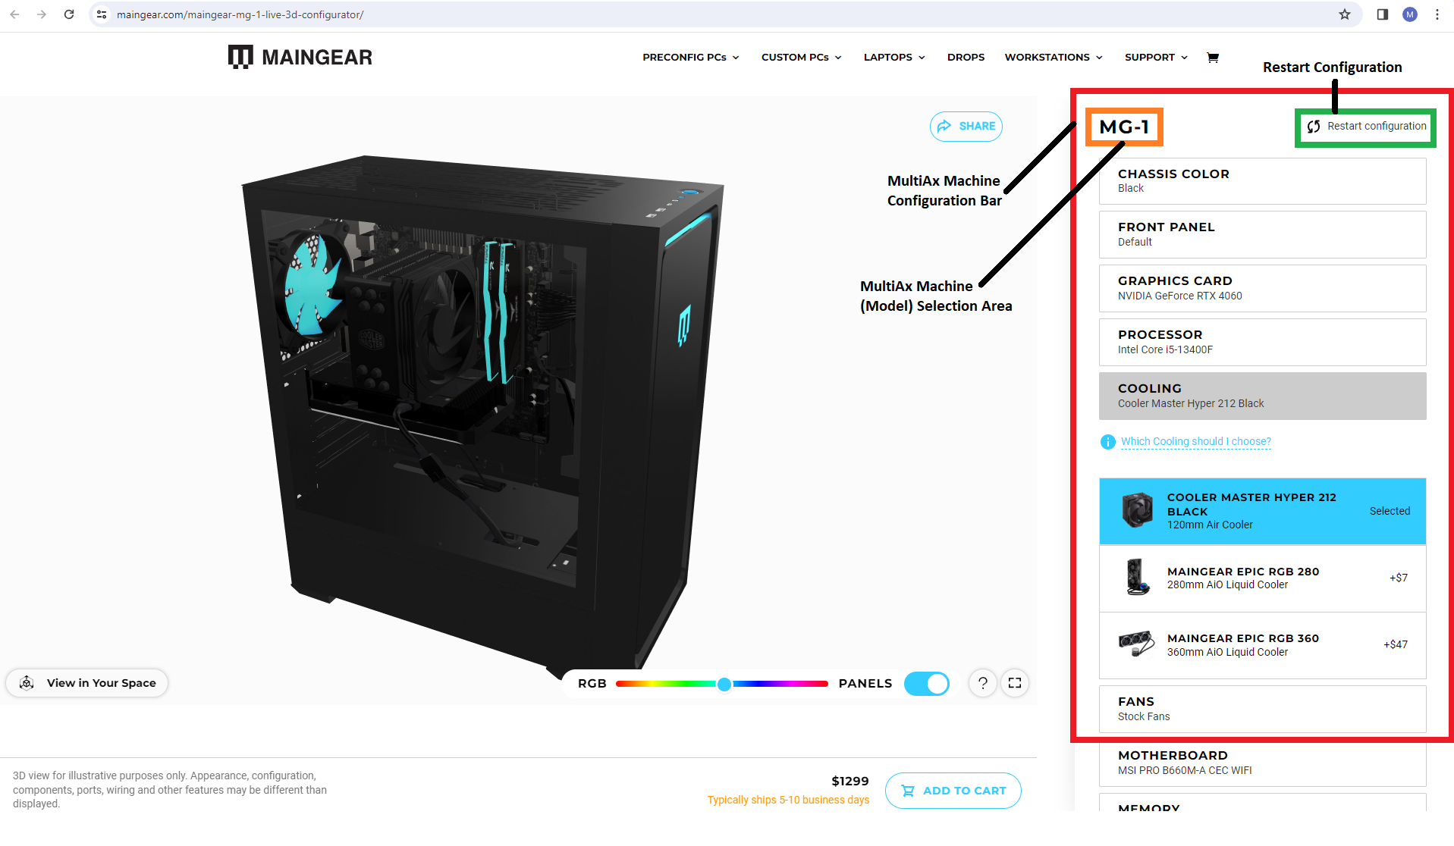

Image-2

- User can select the Machine model from their side like MG-1 and once the selection will be done, all the layers will be visible (Parts option or Sub-Assemblies) in the form of layer tree same as the Image-2.
- Restart Configuration option will be visible for the User.
- Color and Texture scheme will be same as the GLB files.
- If we can add the 3D Views of the Sub-Assemblies and Parts that will be good.
- Visualization of Assembly with all selection must be clearly visible in the 3D Area.
- Parts and Sub-Assemblies will be in the USD, when user add it into the configuration it will be added in the final quote.
- Final output will be the complete Information w.r.t finalized assembly and attachment of the Invoice.

MultiAx Machines Models Information
Currently we have two MultiAx Machines Models as follows:
- MultiAx Machine Model NE 1104-3818 (Completed Data in all formats)
- MultiAx Machine Model NE1104 – 7618 (Work in Progress)

- MultiAx Machine Model NE 1104-3818
We have complete data of MultiAx Machine Model NE 1104-3818 Includes all the parts and sub-assemblies that client shard with us. These Information Consist as mentioned below:
- Main Assembly of the Machine.
MultiAx Machine Model NE 1104-3818
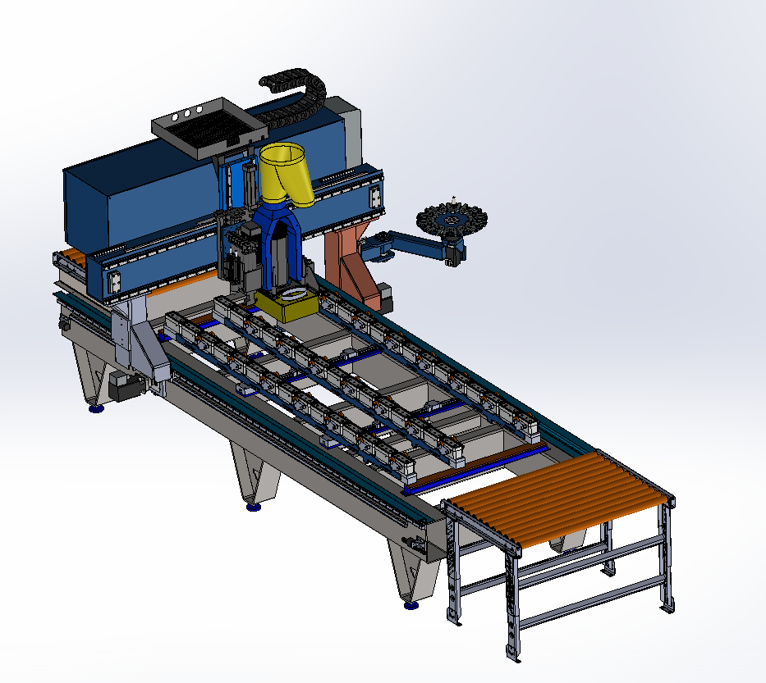

Image-3
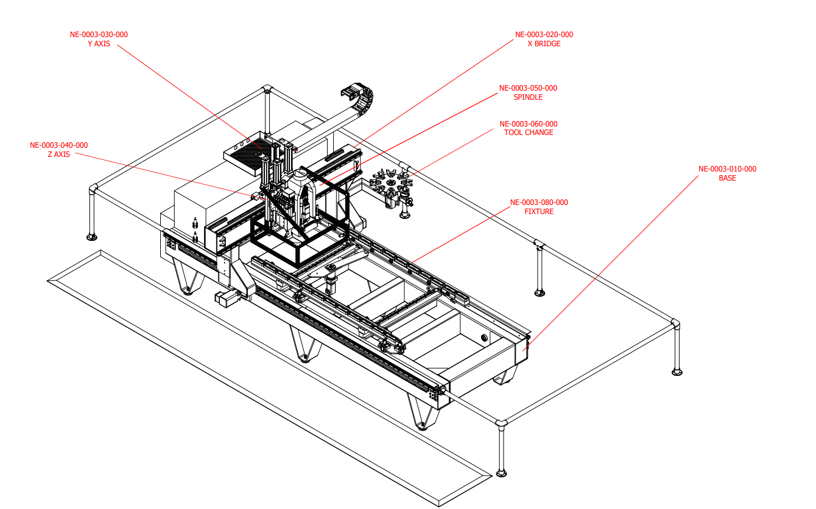
Image-4

- Sub- Assemblies.
Sub-Assemblies of the Machine consists of following data:
Sub Assembly Model Number | Name of Sub Assembly
NE-0003-010-000 | Base
NE-0003-020-000 | X Bridge
NE-0003-022-000 | RIGHT BRIDGE RISER
NE-0003-021-000 | Left Bridge Riser
NE-0003-030-000 | Y Axis
NE-0003-040-000 | Z Axis
NE-0003-050-000 | Spindle
260001001500 | DUST BRUSH ASSEMBLY
NE-0003-060-000 | TOOL CHANGER
NE-0003-080-000 | FIXTURE
 | Rollers with Supports
 | Safety Fence (In Progress)
 | Control Panel (Data Awaited)

All the parts and sub-assemblies Information is included in the excel file named: MultiAx Machine Recreated Parts Information Model NE 1104-3818
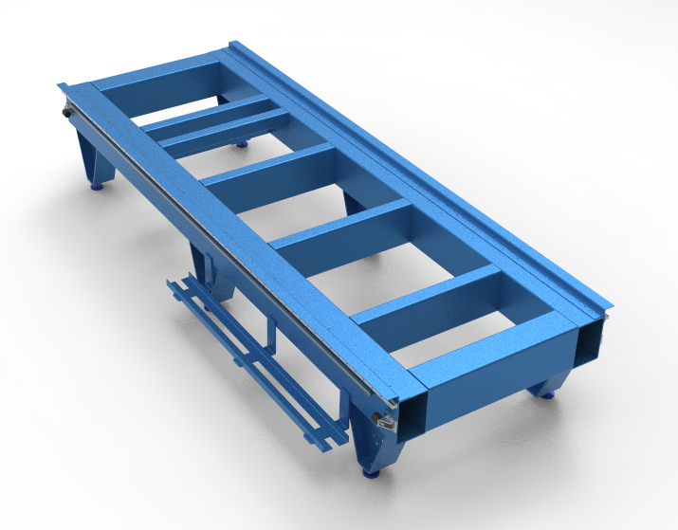

NE-0003-010-000 Base
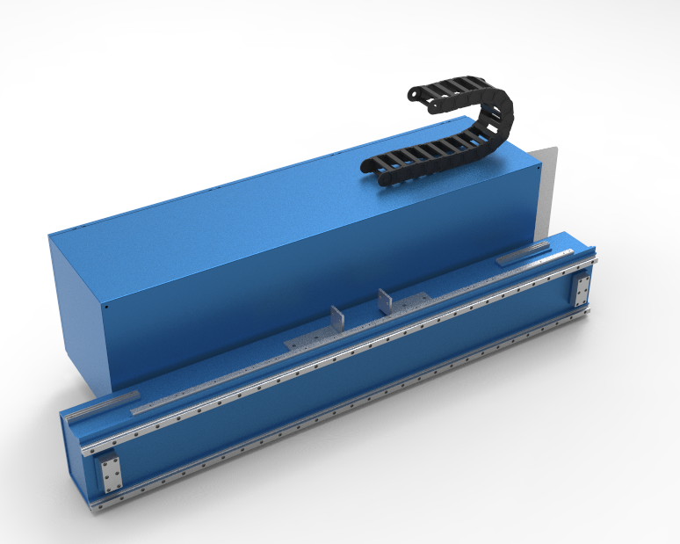
NE-0003-020-000 X- Bridge
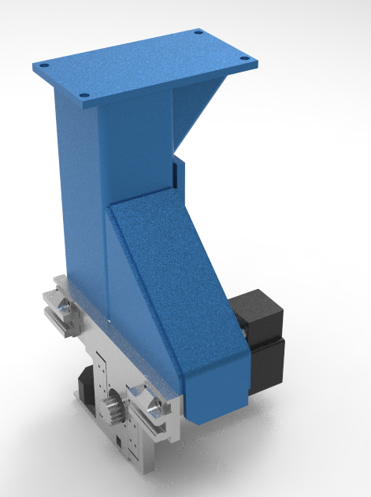

NE-0003-022-000 Right Bridge Riser
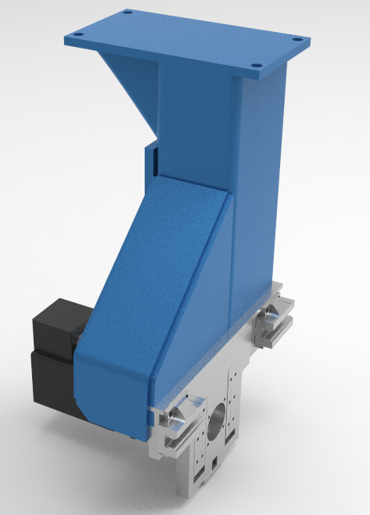

NE-0003-021-000 Left Bridge Riser
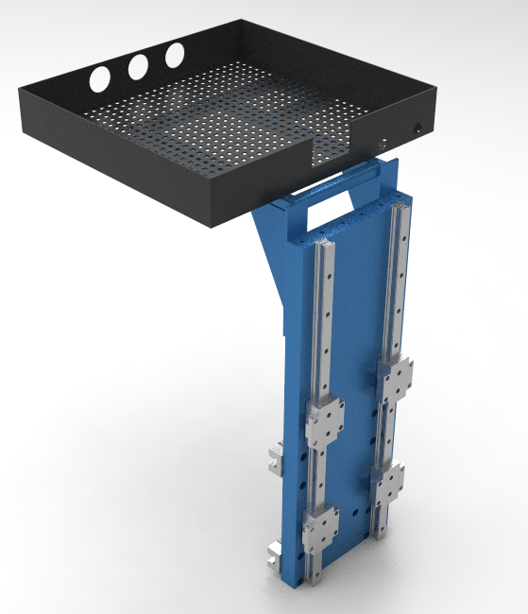

NE-0003-030-000 Y- Axis
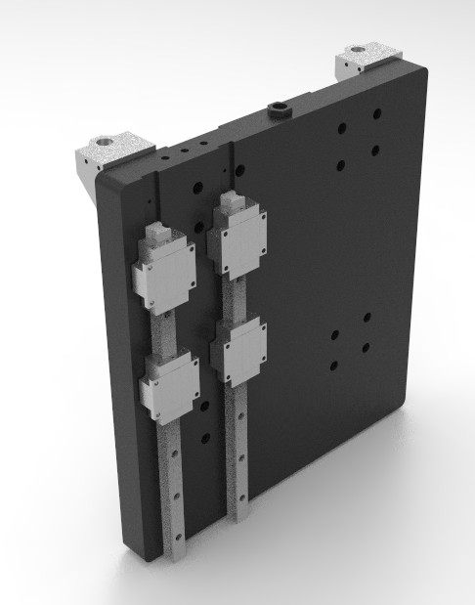

NE-0003-040-000 Z-Axis
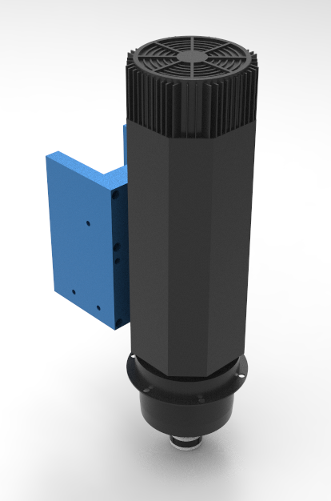

NE-0003-050-000 Spindle
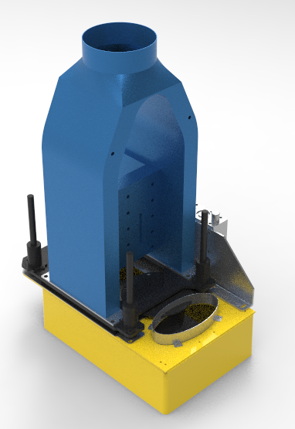

260001001500 Dust Brush Assembly
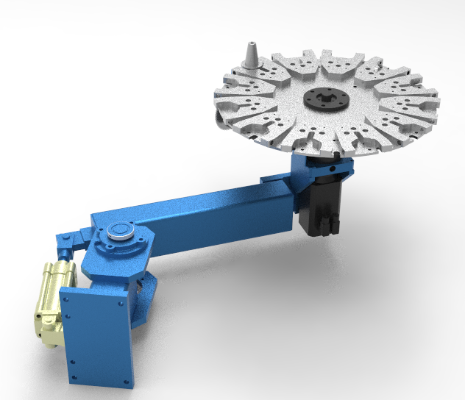

NE-0003-060-000 Tool Changer

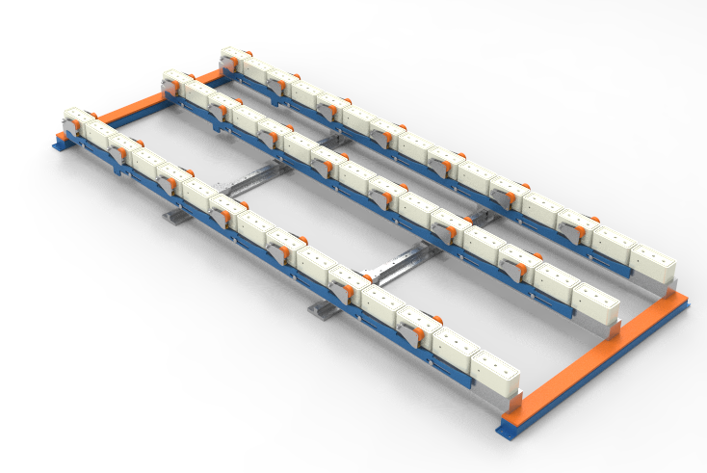

NE-0003-080-000 FIXTURE

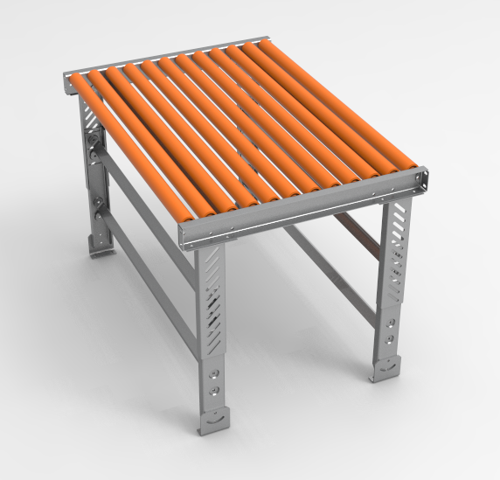

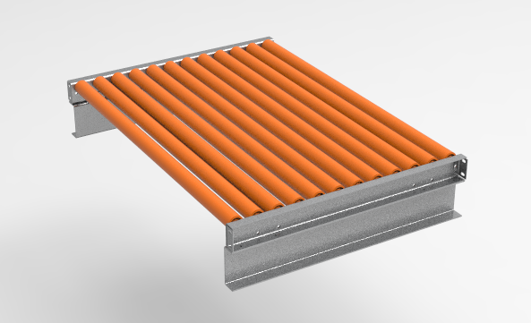
Roller Assembly with Base Mounting
Roller Assembly without Base

